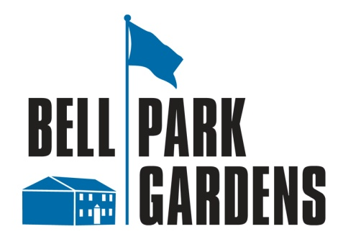

STORAGE LOCKER PROGRAM INFORMATION
PURPOSE:

This notice has been developed to inform residents of the proper procedures for obtaining a lease for individual storage lockers in storage rooms throughout Bell Park Gardens.

VIEWING THE SAMPLE INSTALLATION:

The sample locker installation is located at the building # 13 laundry room area, 67-02 218 St. You may view the lockers from 9:00 AM until 7:00 PM daily.

GENERAL INFORMATION:

Lockers will be located throughout the site, in rooms designated for storage purposes. Not all basement rooms are capable of having separate locker rooms. Some lockers will be located in laundry room areas. Lockers in laundry rooms, will be separated by partitions from the laundry area. We expect that at least one room in each building will accommodate locker installations. Except for the sample lockers already constructed, the new lockers will be built on an as needed basis, depending upon requests by shareholders.

The lockers are made of steel wire panels covering three square feet of floor space and are approximately seven feet tall. Shareholders may request multiple lockers, subject to availability and location limitations. All requests are subject to review. The cost is $25.00 per month for each locker. Some lockers may be double sized with a single access door. These lockers cost $50.00 per month. Lockers must be locked with a combination or key pad lock provided by the shareholder.

Shareholders with any existing exterior sheds, which must be removed, will be given preference for lockers.

ACCESS:

Once leased, all lockers will be accessible from 9:00 AM until 8:00 PM.

Emergency access may be provided, by the security officer on duty from 9:00 PM until 4:00 AM for a fee of $50.00. From 4:00 AM until 8:00 AM may be provided by maintenance staff at a cost of $150.00. All billing will be applied to your monthly maintenance statement.

LICENSE DOCUMENT:

Once your application is reviewed and approved, you will be provided with a storage locker license document for execution. The document contains all information relevant to the storage locker program, including rules about what may not be stored in the locker. You must be in "good standing" in order to receive or keep any locker. This means your maintenance account must be paid in full at all times.

LEASING PROCEDURE:

If you are interested in leasing a storage locker, download the storage locker lease request form below, then scan and send it to forms@bellparkgardens.nyc for processing. The office will contact you.

Shareholders with no internet access should contact the management office for assistance.

Bell Park Gardens Management Office

STORAGE LOCKER REQUEST FORM

ADDRESS: Click here to enter text. | BUILDING: Click here to enter text.
LAST NAME: Click here to enter text. | FIRST NAME: Click here to enter text.
EMAIL: Click here to enter text.
PHONE: Click here to enter text. HOME ___ CELL ___ WORK ___
NUMBER OF LOCKERS REQUESTED: Click here to enter text.

I request assignment of storage lockers at the location indicated above.

I understand that my maintenance account will be charged $25.00 per locker (or $50.00 for a double sized locker) starting on the date of occupancy.

Click here to enter text. | Click here to enter a date.
Shareholder signature | Date

------------------------------------------------------------------------------------------------------------------------------------
FOR OFFICE USE ONLY
DATE RECEIVED
LOCKER(S) ASSIGNED_______________________

LOCKER LICENSE(S) SIGNED_________________

NOTES_____________________________________

___________________________________________

___________________________________________

